Technical Design
for
Citigroup

HR Onboarding application

Version 1.2
February 1st, 2008

Statement of Confidentiality
This document has been prepared in response to the requirements study and functional analysis completed with Citigroup. Information contained in this document is company confidential and may also constitute trade secrets of Adobe. The contents of this document may not be duplicated, used or disclosed in whole or in part without written permission of Adobe. Citigroup shall have the right to duplicate, use, or disclose the data contained herein to the extent provided in the contract. All data contained in this document are subject to this restriction. Notice regarding this document should be directed to the Adobe Consulting Project Manager.

Revision and Related Document Change Log
Document Revisions
Revision Number | Date | Page(s) Affected | Comments | Author
1.0 | November 5th, 2007 | All | Initial Version | Miroslav Lukic
1.1 | January 8th, 2008 |  |  | Miroslav Lukic
1.2 | February 1st, 2008 |  | Added updates regarding “task id” and “password generation” enhancements | Miroslav Lukic

Related documentation
Document name | Version number | Date | Comments | Author
Process Overview |  | October 20th, 2007 | Created based on the discussion held between Adobe and Citigroup | Guy Warwick, Miroslav Lukic
Hire Process Flow |  | October 20th, 2007 |  | Guy Warwick, Miroslav Lukic

Glossary
Term | Description
XSD | XML Schema definition file
XDP | Form designed using Form Designer and used by LiveCycle Forms to generate a variety of forms that are rendered either on the server or on the client (such as PDF, PDF Form, HTML)
SWF | Small Web Format – typically consumed by Adobe Flash Player
XFA | XML Forms Architecture – Adobe specification describing XML based forms (XDP files)
DDL | Data definition language – used for defining data structures

Table of Contents
Statement of Confidentiality i
Revision and Related Document Change Log ii
Glossary ii
Table of Contents iii
1 Introduction 1
1.1 Purpose of this Document 1
1.2 Intended Audience 1
2 Overview 2
2.1 Application overview 2
2.2 Logical architecture 2
3 Physical architecture 4
3.1 Application Architecture 4
3.2 Data flow 5
4 Application components 9
4.1 Forms 9
4.2 “Form guide” forms 9
4.3 “PDF” forms 9
4.4 User interfaces 13
4.5 Application database 17
4.6 Processes 18
4.7 Custom components 28
4.8 Repository structure 31
4.9 Interfaces 32
5 Assumptions and risks 33
6 Appendix A 35
6.1 Form templates 35
6.2 Database DDL 36

Introduction

Purpose of this Document
The purpose of this document is to provide details regarding technical design for the HR Onboarding application. The domain of this document is the detailed technical specification of the solution. The document describes that logical and physical architecture for the solution, including detailed descriptions of each solution component.

1.2 Intended Audience
This document is intended for Citigroup IT personnel.

Note: For the purpose of this document, it is assumed that intended audience is familiar with HR Onboarding application and its requirements.

Overview

Application overview
The purpose of this application is to streamline existing HR on boarding process by:

- Automate process of creating and delivering “Application” and “Hire” package
  - Pre populate form(s) with data
  - Determine forms needed in the package
- Enable delivery / acceptance of the packages via:
  - E-mail submission (as standalone PDF document)
  - “On line web forms”
  - Fax / Mail
- Automate process of receiving and processing “Application” and “Hire” package
- Enable integration with the other systems

At the high level, the application can be divided in couple main components such as:
- Data entry interfaces to either enter data, approve/reject/track status of the overall application
- Data entry forms used by “applicant/new hire”. Note that “applicant” / “new hire” is typically the same person – the only difference is whether he/she is entering data in “Application package” (role of “Applicant”) or “Hire” package (role of “Hire”)
- Back end server components used to automate various process (such as package creation and approval)
  - Processes
  - Integration components
Note: The purpose of this document is to cover “e-mail” delivery channel only. Therefore, the rest of the document describes “e-mail” delivery channel in the greater details. However, document takes into consideration additional functionality that may be added in the later phases of the project.
The next sections provide details regarding each of the components mentioned.

Logical architecture
The following diagram illustrates the logical solution architecture. The diagram uses n-tier architecture where:

- The Client Tier includes solution components that are deployed and executed on the end user workstation
  - Microsoft Internet Explorer 6.x on Windows XP
  - Adobe Reader 8.1.x or later – used to render and fill out PDF forms
  - Adobe Flash Player version 9 or later – used to interpret and render SWF content
- The Web tier does not contain any solution components. The web tier is really a pass thru to the application tier for the security purposes. Note that Siteminder would be typically used to perform single sign on. However, integration with Siteminder in not implemented in the current application
- Application tier (Adobe LiveCycle ES) includes solution components that acts as services to the Client tier. Following LiveCycle ES services are identified:
  - LiveCycle Forms ES
  - LiveCycle Process Management ES
  - LiveCycle Reader Extension ES
  - LiveCycle Rights Management ES
  - LiveCycle Barcoded Forms ES
  - LiveCycle Data Services ES
Note that service in “bold” are used for e-mail delivery channel.
- The Data tier includes data stores such as relational databases and directories.
- Designer component – deployed on the designer/developer workstation and used to maintain various application components
  - Adobe Livecycle Workbench ES – Form Designer
  - Adobe Livecycle Workbench ES – Process Designer
The tiers need not map directly to the physical servers. In some cases, a single server may house components for more than one tier. In other cases, the components for a tier may be distributed across multiple servers.

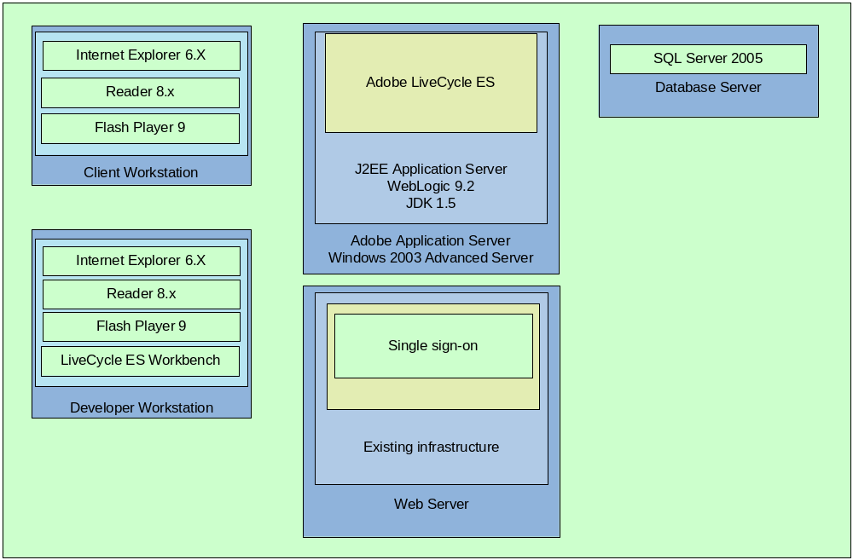

Physical architecture

Application Architecture
This diagram shows the different hardware and software components required to provide functionality as described. Note the diagram concentrates on the Adobe components of the overall solution and interfaces to the relevant Citigroup components. Therefore, some of the “common components” (such as Siteminder and proxy servers) have being omitted. Note that for the purpose of this diagram only single Adobe LiveCycle ES server has being depicted. However, LiveCycle ES can be installed in the clustered environment as well.
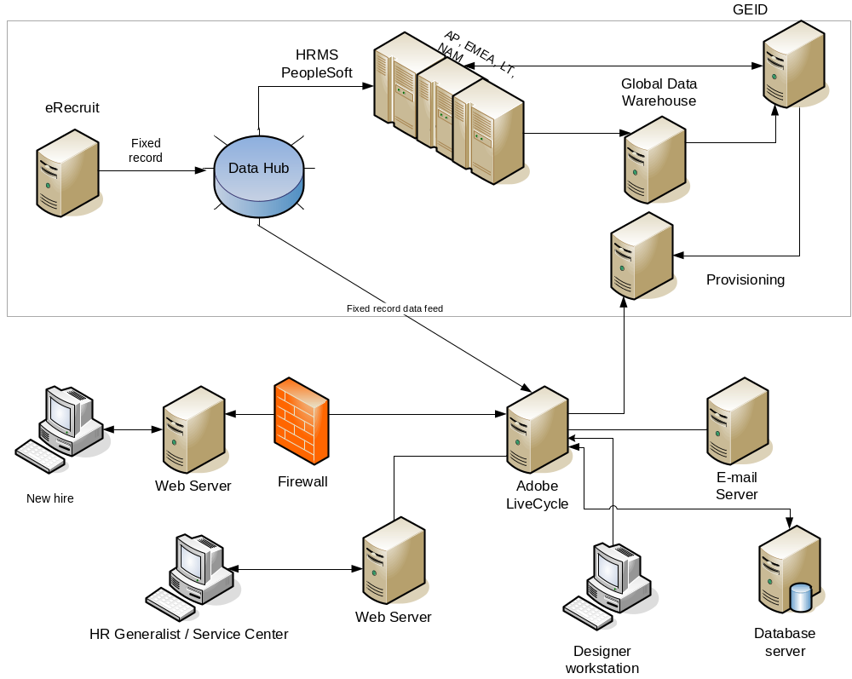

The following table contains hardware and software requirements for the system architecture of the proposed solution. For the purpose of this document, Citigroup UAT configuration has being described.
Server / Workstation | Hardware / OS configuration | Solution software / components
Adobe LiveCycle Server | Windows 2003 Server  Weblogic 9.2 | Adobe LiveCycle ES  XDP templates (in repository)
Database Server | SQL Server 2005 | Application specific tables  Adobe LiveCycle ES database
e-mail Server | Existing configuration | LiveCycle ES dedicated e-mail accounts
Web server | Existing configuration
“Citigroup servers” | Existing configuration
End user workstation  (internal users) | Windows XP | Microsoft Internet Explorer 6.x  Adobe Reader 8.1 or later  Adobe Flash Player version 9 or later
End user workstation  (external users) |  | Adobe Reader 8.1 or later
Designer workstation | Windows XP | Microsoft Internet Explorer 6.x  Adobe Reader 8.1 or later  Adobe Flash Player version 9 or later  Adobe Workspace ES

The difference between “internal” (Citigroup) and “external” users is following:
- “Internal” users are using Adobe LiveCycle ES Workspace so Adobe Flash Player version 9 is required
- “Internal” users are using “controlled desktop environment” so specific operation system (such as Windows XP has being chosen)
- External users need to use Adobe Reader 8.1.1 only. Detail system requirements for it could be found at
http://www.adobe.com/products/reader/productinfo/systemreqs/index.html#80win
Note that for the initial phase of the project following is assumed:
- There is no initial data feed from Citigroup components to LiveCycle components
- There is no integration with Citigroup back end systems
- It is anticipated that some of that functionality may be added in the later phases of the project.

Data flow
Overall data flow has being described in the diagrams below. Note that following should be taken into consideration:
- Detail description of the overall process can be found in the document named “Process Overview” (please refer to related documentation)
- The first diagram below incorporates all delivery channels. As noted before, this document details only e-mail delivery channel. Therefore, the second diagram describes only e-mail delivery mechanism.

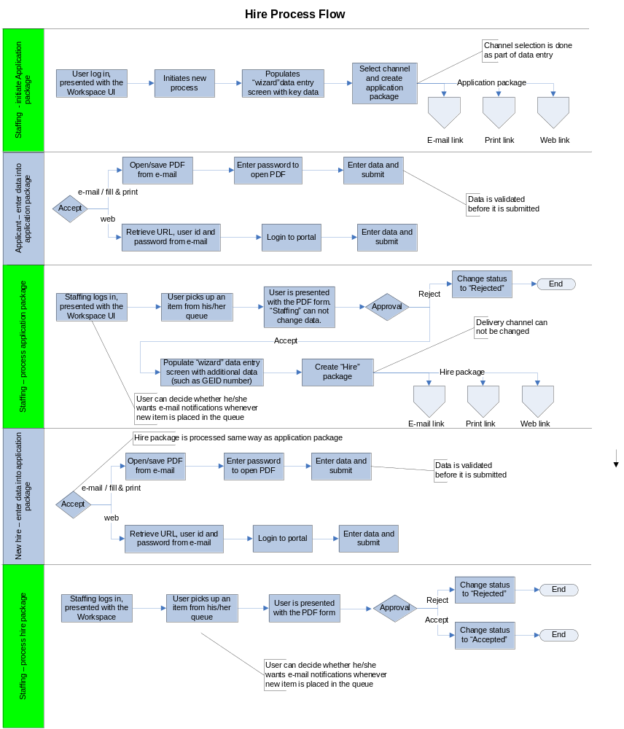

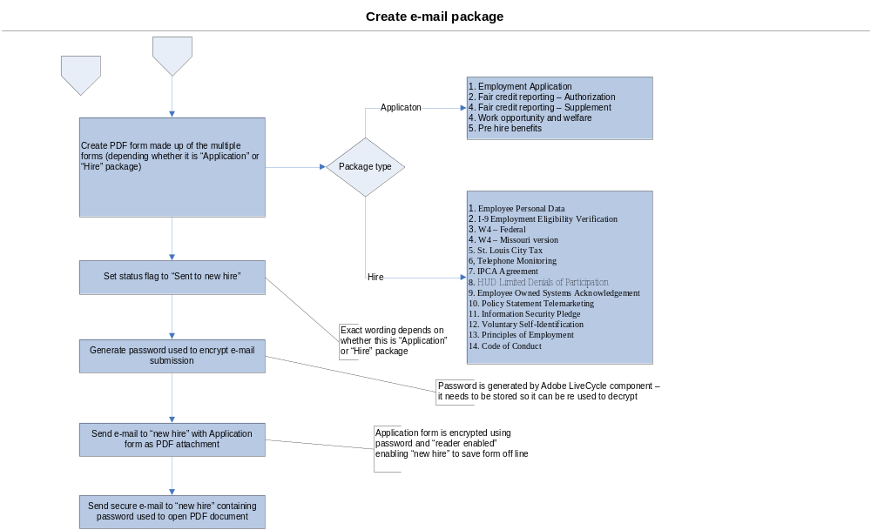

At the high level, data flow in the application is as follows:
- A “Staffing” person logs in to Adobe LiveCycle Workspace ES (as described in 4.4.2), a web based application running in the browser (such as Internet Explorer)
- “Staffing” person starts new process and it presented with a user interface (as described in 4.4.3) that enables him / her to enter basic data (such as applicant name, applicant address, applicant e-mail address) and choose delivery channel (e-mail, web, mail).
- After entering data, “Staffing” presses “Complete” button that will initiate process of creating Application package (for more details please refer to 4.6.1).
- After Application package is created two e-mails are sent to “applicant”:
- The first one contains application package as PDF attachment. Default subject line is in the following format (depending on the package type). Note that “staffing” role can modify “subject” line as part of the UI
Application package
Hire Package
- The second e-mail contains password required to open PDF document. This e-mail is typically sent using Citigroup secure e-mail service.
- Regardless of the package type, “applicant” enters the data in the form(s) and submits data back (as described in 4.4.1).
- “Staffing” is able to either approve or reject application package
- In case of rejection, application package is sent to dedicated queue.
- In case of acceptance, “staffing person initiates creation of the Hire package by populating similar interface as the presented in step 2 (for more details please refer to 4.4.3). Steps 3 and 4 are repeated except for the following differences:
- Number of forms in the package is different
- Password is different
- “New hire” enters data in the PDF file and submits data back.
- “Staffing” person either accepts or rejects Hire package.
The next section provides more details regarding application components and their functionality. Note that in addition to components mentioned above, various other component required to support described functionality are described as well.

Application components

Forms
Form templates can be divided into two main categories:
- Forms to be rendered as form guide
- Forms to be rendered as PDF forms as part of the either Application or Hire package

“Form guide” forms
This form is rendered as “form guide” (SWC) to the “Staffing” person responsible for entering initial data about applicant/new hire (for more details please refer to 4.4.3). Therefore, end user requires Adobe Flash Player 9.x to consume this form. Following is assumed regarding this form:
- It is bound to the same schema as the other forms. This approach enables XML data to be easily shared between “form guide” and PDF forms
- It contains only fields that need to be presented as part of the user interface (for more details please refer to 4.4.3)

“PDF” forms
These forms are rendered as PDF forms within form package (for complete list of forms please refer to 6.1). Following should be taken into consideration when designing them:
- Forms are not rendered standalone but as part of the bigger package
- Number of forms in the form package varies (depending on the business rules). Therefore, these forms need to be assembled into single XDP before being rendered as standalone PDF package
- Form designer is able to design, test and maintain these forms as separate objects
Based on constrains mentioned above, the next couple section provide form design guideline (4.3.1) as well as describe recommended validation approach taken (4.3.4).

Form design guidelines
Due to constrain mentioned above (4.3), following assumptions/guidelines are implemented during design phase:

- All fields on all forms are mapped to single XML schema definition (XSD)
- All fields pointing to the same node within the XSD are treated as “global” fields (value entered into one field is shared with the other fields mapped to the same node)
- Name of the top level subform (“page level subform”) as well as master page for each form must be unique across all forms. Following is recommended:
  - Each form should contain single top level (page) subform. Note that multiple subforms could be added underneath “page” subform
  - Form name should be used as part of the top level subform and/or master page name in order to ensure it is unique
- Each form has “generic” “Validate” (btnValidate) button. The purpose of “Validate” button is to execute document level validation for the specific form.
- In the final version, “Validate” button is invisible to the end user at the form level
- “Validate” button on the first form in the package (“cover page”) is used to validate all forms within package (as described in 4.3.5)

Form fragments
Form fragments are reusable components of a form or document such as a group of form fields or a script object. When a fragment is updated, the form and document templates that reference it are automatically updated as well.

For the purpose of the pilot, Citigroup will identify one static form fragment without any data entry fields. This fragment will be utilized during form design in order to show form fragment functionality.

Note: Due to time constrains, form fragments are not implemented in the current phase.

“Cover page”
“Cover page” is always the first form in the PDF package. Following are some of the rules regarding this form:
- It contains legal text as well as common buttons such as:
  - “Save” button allows the end user to save PDF locally
  - “Print” button allows the end user to print PDF to printer
  - “Validate” button allows the end user to validate all “business rules” within entire package
  - “Return package Instruction” button provides instruction to the end user regarding submission process. Note that this button is initially “grayed out” till all validation errors are rectified.
- It contains scrollable multi line field (named Error) used to display results of the validation routine
- It contains common script objects (and form variables) containing routines used to perform various validations. These routines can be used by other forms.

Validation approach
There are two basic types of validation:
- Field level validation is typically triggered at the field::exit event and results (typically) in the message box being displayed to the end user. Depending on the end user requirements, the end user may be trapped in the field till he/she fixes mistake.
- Package (document) level validation is typically executed before form is submitted to the back end. In case any error is encountered, package can not be submitted.
Following approach is implemented:
- Field level validation is not implemented
- Package (document level validation) is executed on the button::click event before XML data can be submitted to the server side components (for more details please refer to section 4.3.5)

Document level validation
In the case of the “standalone PDF package”, number of forms in the package is unknown. Therefore, any validation approach must be generic enough to handle validating unknown number of forms after “cover page”. Following approach is implemented:
- “Validation” button on the “cover page” is used to execute package level validation for the complete package using the following routine:
  - Invoke generic routine checkMandatoryFields()to identify missing mandatory fields within complete package
strTemp = checkMandatoryFields(false, true);

  - Execute form level validation for each form by invoking following code snippet
data.F515.Page1.btnValidate.execEvent("click");
if (strFormValidationMsg.value != "") strTempVal = strTempVal + strFormValidationMsg.value;
where:
    - data.F515.Page1 identifies top level subform in the particular form
    - btnValidate is the name of the button containing form specific logic for the particular form. Result of the validation routine executed on btnValidate::click event is typically stored in string. The value of the string is passed to the main routine using form variable defined in the “cover page” (strFormValidationMsg) and added to the string containing validation errors (strTempVal)
- Construct and display (in case of errors) “final” validation message in the scrollable field (named Error) on the “cover page”. This is done by combining values in two variables:
  - strTemp contains missing mandatory fields
  - strTempVal contains failed business rules (such as invalid field values)
- If there are no errors, “Return Package Instructions” button becomes available providing the end user with the instruction about submission process. The end user can submit the PDF by executing the following steps:
  - Save PDF locally
  - Open e-mail client application (such as Outlook, “web based e-mail client”)
  - Attach PDF to the e-mail
- In case of the validation errors, following behavior is implemented (as depicted on the picture below):
- Missing mandatory fields have red borders (RGB value “"255,255,255")
- Fields with invalid data (such as SSN in the example below) have blue borders ((RGB value “"1,169,233")
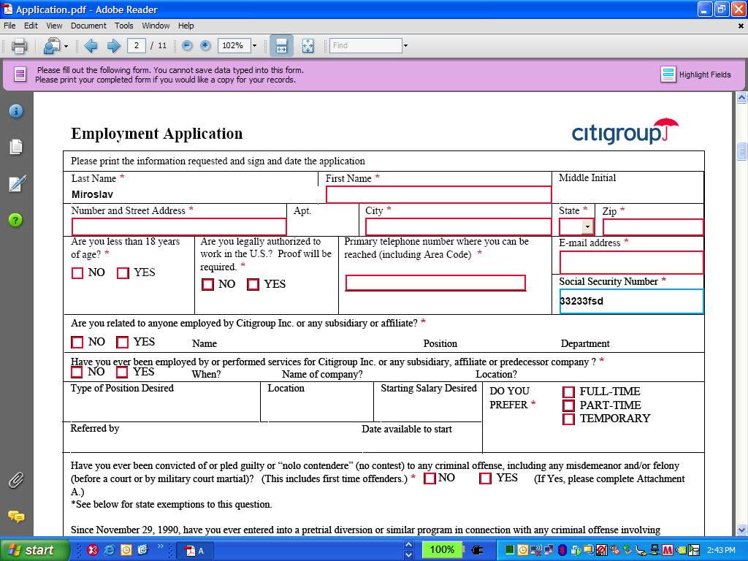

Schema definition (XSD)
Schema definition (XSD) is used as “abstraction layer” that enables clear separation between presentation layer (form templates) and data layer (XML data being submitted back and forth). During form design process, form fields are bound to the schema enabling various application components to produce/consume XML that adheres to XSD.
For the purpose of this application Adobe will develop common XSD with the following assumptions:
- There will be only one XSD and all forms are bound to the same schema.
- XSD will utilize nodes (as opposed to attributes).
- There will be no repeating elements (no max=’unbounded”) in the XSD since all forms are static.
- XSD will follow (as close as possible) form structure in order to take advantage of built in Designer / Reader features. As general rule, complex types should be bound to subforms and nodes should be bound to fields on the form.
- At the high level, XSD will have following complex types:
  - <general> tag will contain all data elements within all forms
  - <metadata> tag will contain various “control” data such as:
    - Names and characteristics of the forms in the package (held in complex type named <forminfo>)
    - Task id
    - Current process status

User interfaces
User interfaces provided by the application depend mainly on the end user role. Following roles are identified in the process:
- Applicant / New hire – this is the same user, the only distinction is whether he/she processes “Application” or “New Hire” package
- “Staffing”
- “Process” users such as:
  - “e-mail user” (emailuser) – his queue is used as placeholder for submitted package
  - Users that can monitor queue containing accepted/rejected packages.
- System administrator
The main difference is that “new hire” is not a “known user” to the Adobe LiveCycle ES. Therefore, “new hire” must be presented with “custom interface” (depending on the type of the form being processed) while, “Staffing” (and other process users) would use “out of the box” Adobe LiveCycle ES Workspace interface.

New hire standalone PDF
Standalone PDF is delivered to “new hire” as PDF attachment to e-mail message. “New hire” must use password (sent in the separate e-mail) to open PDF file. The end user uses Adobe Reader 8.1.1 standard interface to fill out form and submit it. Note that since PDF form is “reader enabled”, additional capabilities (such as saving form offline) are enabled. In addition to standard Adobe Reader functionality, following buttons are added to the first page within application package:
- “Validate” button verifies data entered across all forms (without submitting it)
- “Save” button invokes standard “Save As” dialog box allowing “new hire” to save PDF on his/hers local computer.
- “Print” button invokes standard “Print” dialog box allowing “new hire” to print PDF to any printer accessible from local computer
- “Return Process Instructions” button provides the end user with the instructions regarding form submission process. Note that PDF must be submitted to the e-mail address monitored by Adobe LiveCycle ES Process.
Note: “Save” and “Print” operations can be invoked using standard Adobe Reader functionality as well.

Staffing – approval UI
The purpose of this interface is enable “Staffing” to process incoming application received from new hire and tracks their status. For the purpose of the pilot application, Adobe LiveCycle ES Workspace interface is used. It is anticipated that only minor changes to this interface will be performed for the initial phase of the project:
- In addition to “standard” values displayed in the Workspace UI (such as process name, description and so on), new hire’s “first name”, “last name” and GEID number as well as current applicant status will be exposed as well through Process Management. This would allow “staffing” to easier find “new hire” package and/or its status.
- “Staffing” (or any other “workflow” user) is still able to customize Workspace outlook by using options within Preferences.
Following picture shows default Adobe LiveCycle ES Workspace that would be used throughout the process. Note that two processed can be found within “CitiHR” category:
- “Process Packages” is main approval process
- “Search Password” is used to retrieve password(s) used to encrypt PDF document
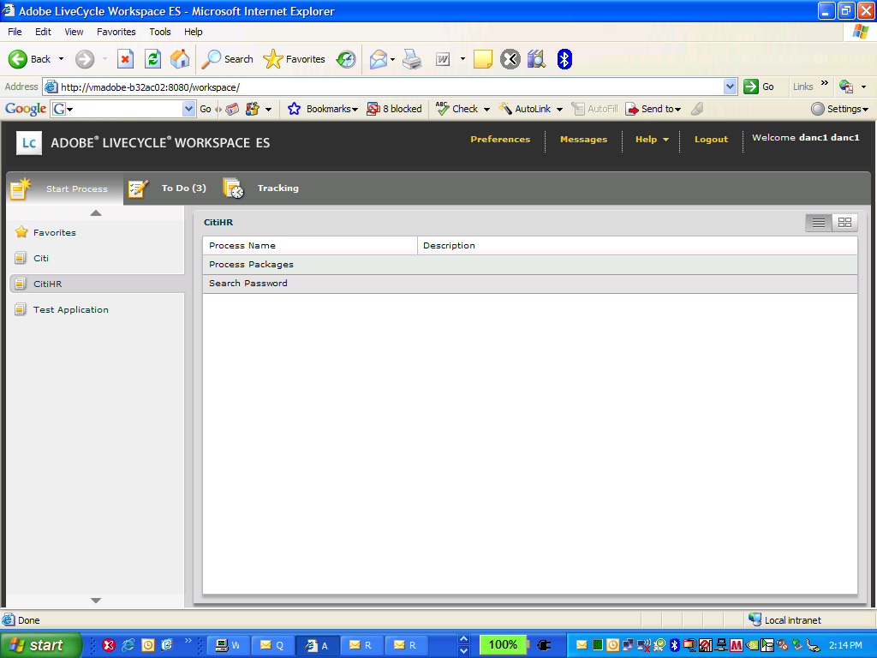
Depending on the Citigroup setup, it is expected that multiple users may share same queue so the user needs to claim work item before he/she can work on it.

Staffing – data entry UI
The purpose of this interface is to:
- Enable “Staffing” person to enter initial data about applicant (this it typically done before Application package is sent to “applicant”)
- Enable “Staffing” to enter additional data (such as GEID number) about new hire before Hire package is sent
- Enable “Staffing” to submit XML data to the back end components and initiate creation of the e-mail messages to “applicant”/“new hire”
- Enable “Staffing” to approve/reject packages
Upon starting new “Process Packages” process, “Staffing” is presented with the interface showing data entry panel similar to the one shown below:
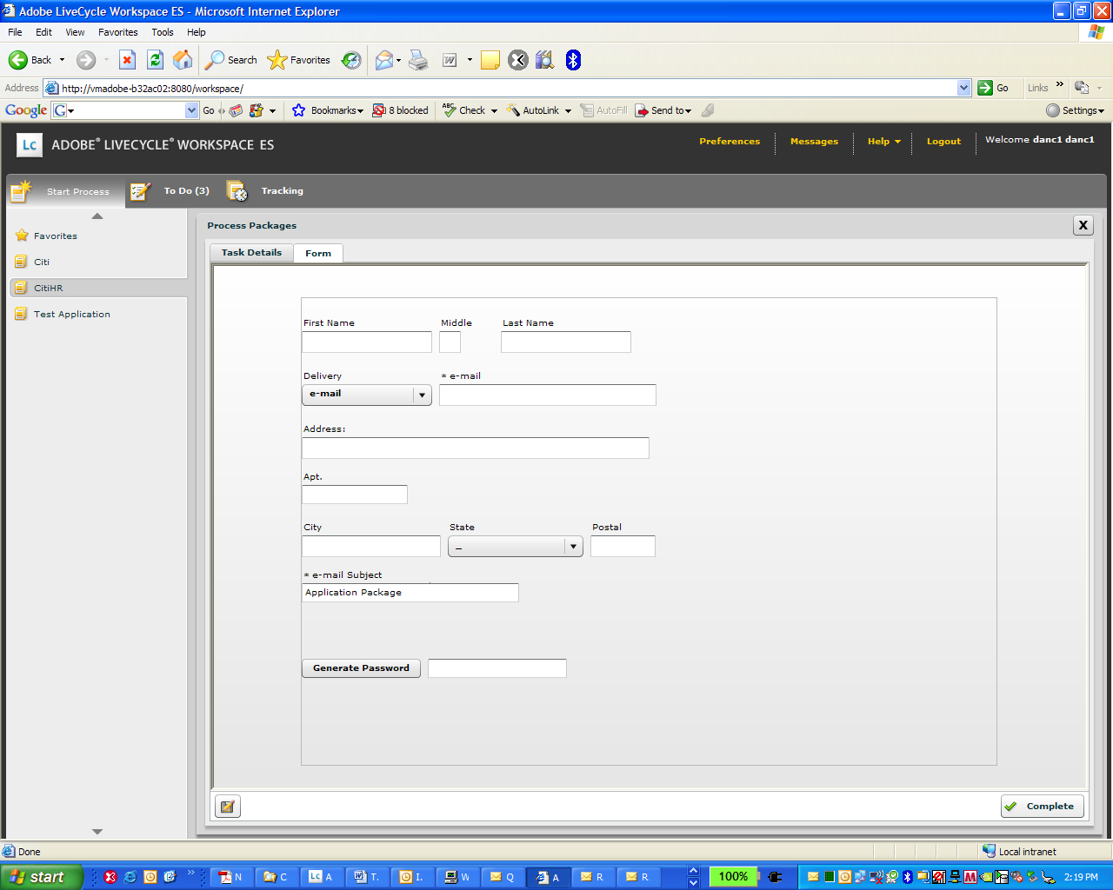
It is anticipated that “Staffing” will enter only “basic” data such as:
- Applicant first, middle and last name
- Applicant address
- Applicant e-mail address (mandatory field)
- Delivery mechanism (for the initial phase the only valid option would be e-mail)
- GEID number (visible and mandatory field before “new hire” package is created)
- Subject line (mandatory, default value is provided)
- Generate password (by clicking on the button named “Generate Password”) used to encrypt document (mandatory, read only). It is anticipated that “staffing” person may communicate this password to the “applicant/new hire”
Following functionality is implemented:
- Field/document level validation
- Ability to submit data to the “back end” server side components (by pressing on “Complete“ button)
- Pre populate data entry form with existing data (in the case of entering additional data for “hire” package)
- Bind field objects to common schema in order to enable data to be shared
In addition to this interface, “staffing” will be presented with PDF form interface within Adobe LiveCycle ES Workspace interface.

Staffing – retrieve password
The purpose of this interface is to enable “staffing” role to retrieve password for specific user. It is invoked from SearchPassword process. “Staffing” role can search based on:
- First Name
- Last Name
- e-mail address
- Package type
The results are presented in the same form.
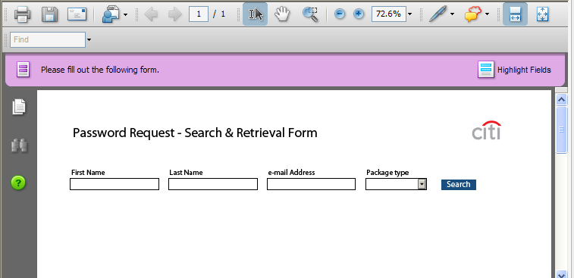

Application database
The purpose of the application database is to hold application specific information. Note that Adobe LiveCycle ES component uses different database instance to store LiveCycle resources (such as processes, components and so on). LiveCycle specific database is created and configured as part of the installation procedure.
Note: DDL for tables described below can be found in paragraph 6.2.

Forms and Packages table
The purpose of these tables is to hold relation between Forms and Packages utilized in the application. This data is utilized in ProcessPackages process to figure out forms that need to be part of the package. Following is assumed (for the pilot phase):
- Forms table contains data for the forms to be utilized in the solution. For the pilot phase, it contains “form data” for all of the forms identified in Appendix A
- Packages table contains information for the packages used in the solution. For the pilot phase, it will contain data for application and hire package.
- “Many to many” relations between Forms and Packages is resolved by creating additional table
- Tables are pre populated “manually” (via SQL insert statements). Details regarding content stored in the tables can be found in section 6.2.
The diagram below provides high level database design required to support functionality described above.
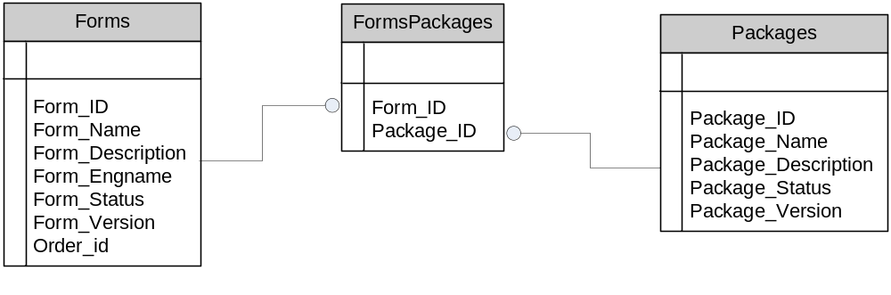
In the later phases on the project this functionality can be:
- Extended by providing some kind of application to manage tables mentioned above (such as an ability to add/modify/delete forms/packages)
- Replaced by incorporating rules engine that would determine forms that are supposed to be in the package based on the identifiers in the XML

Password table
The purpose of this table is to store password information as well as key data used to search for password. The interaction with this database is happening in multiple processes:
- GetPassword (as described in 4.6.8) is used to retrieve data from this table
- “Update DB” task in ProcessExternalEmail is used to insert data into this table
The table itself is not connected with any other tables within database.

Processes
The purpose of this section is to describe various processes implemented to support required functionality. Following is the list of processes implemented:
- ProcessPackages
  - EventEmailPackage
  - RenderGuide
  - RemovePassword
  - RemoveRE
  - AppllyPasswordRE
  - ProcessExternalEmail
- SearchPassword
  - RenderPDF
  - GetPassword
Note that processes are described from the “back end” perspective (for the overall process description from the end user perspective refer to section 3.2).
Following should be taken into consideration:
- Process Packages is main process used to call other process within “main” approval process
- Search Password in the main process used to retrieve password information from database. It invokes other processes (such as RenderPDF and GetPassword) to accomplish it
- When one process calls other, input and output variable need to be defined (as it was done in the various steps in Process Package)
- Input / output process variables are defined for each process in the tables below. Additionally, some of the key variables are defined in the document as well.

Process packages (Process Packages)
The purpose of Process Package process is to automate process of creating and approving various “form packages” that need to be populated by “applicant/new hire” and processed by “Staffing”. Majority of the functionality within this process is implemented by calling other processes (such as the one mentioned above).
Following tables list some of the main process variables, their type and description:
Name | Type | Description
staffingFG | xfaForm / Input | Identifies XDP template to be rendered as “form guide”. It is set to /CitiHR/Forms/NewHire.xdp
inXML | Xml | Contains XML being submitted from “form guide”
stitchedXDP | Document | Contains XDP/PDF (depending on the step in the process) to be served back to the calling application
sqlStatement | String | SQL statement to be executed in order to retrieve names of the forms that need to be assembled
properties | xml | Contains content of the properties file
newpassword | String | Contains password used to encrypt PDF document

The process logic execute as follows:
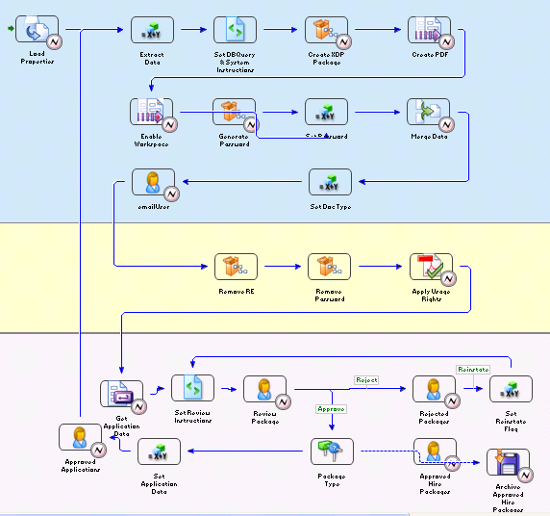
- Process is started by “staffing” logging into system and invoking data entry form (similar to one described in 4.4.3). The form to be presented is defined in the process variable named staffingFG of type xfaForm
- Properties are loaded into process variables using LoadProperties component (described in 4.7.1)
- Invoke RenderGuide (described in 4.6.3) service present “form guide” interface (similar to the one described in 4.4.3) to “Staffing” role
- Upon submission from “form guide” interface, XML data is extracted and saved in XML variable named inXML. After that, multiple steps (identified as steps 5-11) are invoked to create new package
- Use extracted XML data (kept in variable inXML) to determine SQL statement used to retrieve names of the forms to be assembled. SQL statement created is passed to the next step in the process (assembleXDP) as one of the input parameters.
- Invoke AssembleXDPService assembleXDP service to create XDP (as described in 4.7.2) that corresponds to either application or hire package (depending on the step in the process)
- Invoke Form Server renderForm service to render XDP created in the previous step as interactive PDF form. Result of this operation is kept in variable named stitchedXDP
- Retrieve password (send as part of the data stream) and set in the variable named newpassword.
- Merge submitted XML data (kept in variable inXML) with PDF created by renderForm service (in step 7). The result of this operation (PDF form merged with data being submitted) is kept in variable named stitchedXDP
- “Final” PDF form is assigned to different user (named emailuser).
- As soon as task is assigned to emailuser, event listener triggers execution of the EventEmailPackage process (for more details please refer to 4.6.2). Note that at this point, work item has being forwarded from “Staffing queue” to “emailuser” queue.
- After EventEmailPackage is executed, two e-mails (one with password, the other one with PDF attachment) are sent to the “applicant/new hire”
- “Applicant” populates and submits PDF form (as described in 4.4.1) back to the server components.
- e-mail content is processed by ProcessExternalEmail process (for more details please refer to 4.6.7)
- PDF is passed to RemoveRE process (as described in 4.6.4) to remove “reader extension” rights.
- PDF without “reader extension” rights (created in the previous step) is passed to RemovePassword (as described in 4.6.5) process to remove password from PDF
- PDF created in the previous step is assigned to the “Staffing” role that has initiated process
- “Staffing” can either accept or reject application package.
In case of “Reject” route:
  - Send work item to dedicated queue. It is assumed that overall process for dealing with rejection will be implemented at the later phase. In the current release, user monitoring the queue can “re instate” process by sending it back to the “staffing”
  - End workflow
In case of “Accept” route:
  - Proceed with the rest of the workflow. The next steps are exactly the same as steps 3-13 with couple minor differences:
    - “New hire” package is created (as opposed to “Applicant”)
    - “Staffing” is required to populate UI
  - “Staffing” can only accept new hire package. Once package is accepted, it is saved in the file system using GEID number as file name (with extension .pdf)

EventEmailPackage
This process is configured as an asynchronous message event being triggered every time a task has being created in particular process (Process Packages) for particular user (emailuser). Following properties are set:
- Event category – Asynchronous
- Event type – TaskCreated
- Filter setting (setting that must be met to for an event to be received)
  - Process name – Process Packages
  - Process task - emailuser
- Data map settings – used to assign event content to process variables. Following settings are implemented:
  - /process_data/@taskID = /MapContent/TaskID
  - /process_data/@strProcessName = /MapContent/ProcessName
  - /process_data/@strStepName = /MapContent/StepName
  - /process_data/@strTaskEventType = /MapContent/TaskEventType
Following tables list some of the main process variables, their type and description:
Name | Type | Description
taskID | Long / Input | Represent the unique ID of the task
strProcessName | String / Input | Name of the process
strStepName | String / Input | Step name
strTaskEventType | String / Input | Event type
pdfPackage | Document | PDF document representing e-mail attachment
emailAttachment | String | Name of the attachment
Alias | String | passed to ApplyPasswordRE
taskDocument | Document | passed to ApplyPasswordRE
docPassword | String | passed to ApplyPasswordRE

The process logic execute as follows:

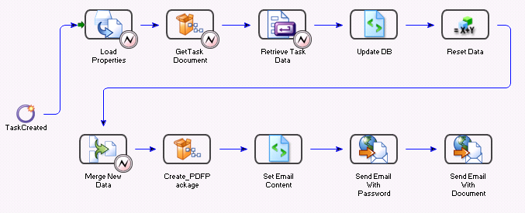

- Properties are loaded into process variables using LoadProperties component (described in 4.7.1)
- Task id (internal process variable used to uniquely identify particular process instance) is retrieved
- Application database table containing password details (for more details please refer to 4.5.2) is updated
- “Create PDF Package” task is used to invoke ApplyPasswordRE process (as described in 4.6.6) to create password protected reader enabled interactive PDF. Note that following variables are “passed” to ApplyPasswordRE process:
  - Alias – alias for Reader Extension service
  - taskDocument - PDF document
  - docPassword – password used to encrypt PDF document
Upon execution, ApplyPasswordRE process returns password protected reader enabled PDF to the calling application.
- “Set email content” script component is invoked to set up content of the e-mail message including subject line. There is logic within this component to determine message content depending on the package type.
- Standard LiveCycle ES EmailServrice Send With Document component is invoked to send both e-mails
  - The one containing password is sent using Citigroup secure e-mail (this is accomplished by placing @@@ signs in subject line
  - The one containing PDF attachment is sent using “regular” e-mail

RenderGuide
The purpose of this service is to render XDP forms as “form guide”. This is accomplished by calling LiveCycle ES FormServer service renderFormGuide component.
Following tables list some of the main process variables, their type and description:
Name | Type | Description
inDocData | Document / Input | XML document to be merged with template
outFormDoc | Document / Output | Document representing rendered guide

The process logic execute as follows:
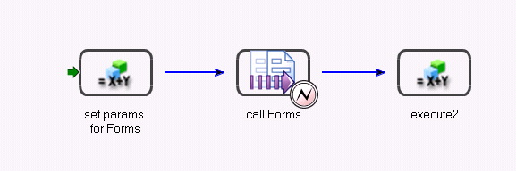

- Input variables are set
- Adobe LiveCycle ES Forms service renderForm operation is invoked to render XDP as “form guide” (SWF file)
- SWF file is returned back to the calling process (in outFormDoc variable)

RemoveRE
The purpose of this process is to remove “usage rights” from the PDF file being processed by ProcessExternalEmail process.
Following tables list some of the main process variables, their type and description:
Name | Type | Description
inform | Document / Input | Input PDF document (password protected and reader enabled)
noRE | Document / Output | Output PDF document (without password)
pass | String / Input | Original password (used to open the document)
inDoc | Document | Internal document variable used to hold PDF document

The process logic execute as follows:
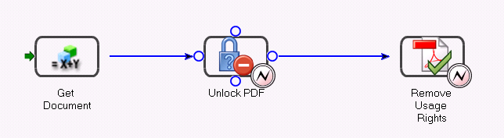
- “Input” PDF passed in document variable inForm is assigned to internal document variable inDoc.
- PDF is unlocked using EncryptionService service unlockPDFusingPassword operation.
- “Usage rights” are removed using ReaderExtensionService service Remove Usage Rights operation
- PDF without usage right is returned to calling process.

RemovePassword
The purpose of this process is to remove password used to encrypt PDF. This is accomplished by calling EncryptionService service named removePDFPasswordSecurity component. At the end of the process, PDF without password is returned to the calling process.
Following tables list some of the main process variables, their type and description:
Name | Type | Description
inDoc | Document / Input | PDF document to be “password protected” and “reader enabled”
Psw | String | Password used to open document
outDoc | Document / Output | “Final PDF” document being returned



AppllyPasswordRE
The purpose of this process is to “password protect (encrypt)” and reader enable PDF.
Following tables list some of the main process variables, their type and description:
Name | Type | Description
alias | String / Input | RE server alias (identifies PFX file)
inDoc | Document / Input | PDF document to be “password protected” and “reader enabled”
inPass | String / Input | Password to be applied
inTaskID | String / Input | Task ID
passOptions | Password Encryption Options | Options used when encrypting PDF
Outré | Document / Output | “Final PDF” document being returned
Note: The first four variables are passed from parent process () as input variables to this process
The process logic execute as follows:
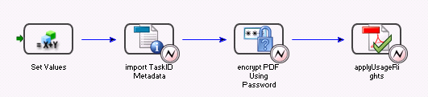

- “Set value” is invoked to set following variables:
- /process_data/inXMP/object/@subject = /process_data/@inTaskID
- /process_data/passOptions/object/@documentOpenPassword = /process_data/@inPass
- /process_data/passOptions/object/@encryptOption = "ALL_EXCEPT_METADATA"
- “TaskID ” variable is added as metadata element to PDF using XMPUtilityService service ImportMetadata component
- PDF file is “password protected” using EncryptionService service encryptPDFUsingPassword component. This service is using encryption option specified in passOption variable (set in the first step in the process). Note that option "ALL_EXCEPT_METADATA" is set to avoid encrypting metadata within PDF document.
- PDF document created in the previous step is “reader enabled” using ReaderExtensionService service Apply Usage Rights component
- “Final” PDF is saved in document variable named outRE and returned to “parent” process (EventEmailPackage)

ProcessExternalEmail
The purpose of this process is process e-mail submissions being submitted from “applicant/new hire”. Note that based on the unique identifier (task ID) is used to associate PDF attached to the incoming e-mail to appropriate process instance.
Following tables list some of the main process variables, their type and description:
Name | Type | Description
attachmentMap | map / Document  Input | Contains list of attachments (assigned through endpoint setup)
taskID | Long | Contains task id
inDoc | Document | Contains content of the PDF
attName | String | Contains name of the attachment
completeStatus | String | Process status

The process logic execute as follows:
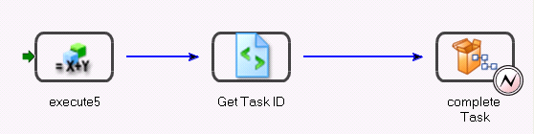

- Process is set up to monitor dedicated “inbox” (defined as “email endpoint” through LiveCycle ES Administrator UI by following Service – Archive Administration – Endpoint Management)
- As part of the setup, attachmentMap variable is mapped to attachment(s) sent as part of the email message. Following variables are assigned:
- /process_data/attName = get-map-keys(/process_data/attachmentMap)
- /process_data/@inDoc = /process_data/attachmentMap[@id=/process_data/attName]
- “Get task ID” script object (for more details please refer to 4.7.4) is invoked to retrieve “task id” from the PDF being retrieved in the previous step and assign it to the variable named taskID.
- Task is automatically completed on the behalf of “emailuser” using Task Notification service completeTask operation. Note that following input properties must be set for this task:
  - task-id points to taskID variable assigned in the previous step
  - user-id point to the internal ID representing e-mail user
  - attachments point to attachmentMap
- After completeTask operation is completed, work item is effectively being moved from emailuser queue to staffing queue. However, as identified in Process Packages, other processes are invoked before work item appears in staffing queue.

Search Password
This process is used by “staffing” role to retrieve data from “password” table.
Following tables list some of the main process variables, their type and description:
Name | Type | Description
Search | xfaForm / Input | Input XFA type form (XDP)

The process logic execute as follows:
- Input XDP form is set to /CitiHR/Forms/SearchForm.xdp
- RenderPDF service (as described in 4.6.9) is invoked to render XDP form (specified in the first step) as interactive PDF. This PDF is rendered within Workspace
- GetPassword service (as described in 4.6.10) is invoked (upon clicking “Search” button) to retrieve information from the database and merge it with the form.

RenderPDF
The purpose of this process is to render “search password” XDP as “reader enabled interactive” PDF form.
Following tables list some of the main process variables, their type and description:
Name | Type | Description
inDocData | Document / Input | Input form to be rendered
outFormDoc | Document / Output | Output form produced

The process logic execute as follows:
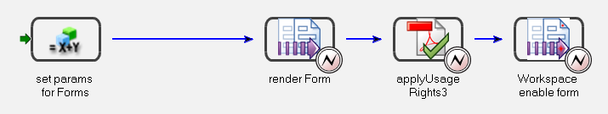
- Various parameters are set
- FormsService service renderPDFForm operation is invoked to merge XDP form with XML data and return back PDF form
- Form generated in the previous step is reader enabled using ReaderExtensionService service Apply Usage Rights operation. This is required to enable form to execute web service calls.
- Form is “workspace enabled” by invoking FormAugmenterService service Inject Form Bridge operation.
- Final result is returned to the calling process in outFormDoc document variable

GetPassword
This process is exposed as web service used to retrieve data from table containing “password information”. It is invoked as web service from “search password” form. The process itself invokes script component containing code to retrieve data from database.


Custom components
The purpose of this section is to define “custom” server side component developed as part of the solution. These components are typically invoked by various processes (identified in section 4.6)

Load properties
This component will be invoked by various processes as the first step in the process. The purpose of this component is load properties from the external “configuration” file into XML type variable so it can be referenced in the process. Configuration file is stored in Adobe repository (as described in 4.8) and it is named NewHireProperties. Here is structure of the configuration file:
<property>
<HomeEmail>administrator@localhost</HomeEmail>
<Alias>ADOBE090831</Alias>
<DSN>java:CITI</DSN>
<EJBENDPOINT>jnp://localhost:1099</EJBENDPOINT>
<ServerType>JBoss</ServerType>
</property>
Each node in “configuration” file is loaded in various processes as process variables to avoid “hard coding” any values in various solution components.

Assembly
The purpose of this component is to assemble multiple XDP documents into single XDP representing corresponding package (either application or hire). Following is assumed regarding this component:
- It is implemented as standalone Java package (JAR) named xdpassembler.jar
- Component is named com.adobe.livecycle.AssembleXDP
- Operation exposed is assembleXDP
- XDP templates are assembled in the order they are passed in
- XDP templates are retrieved from Adobe repository
Following table list input and output parameters:
Name | Type | Description
dataSource | String – input | Database connection string
sqlStatement | String – input | SQL query string used to retrieve list of forms from database
sourceURI | String – input | Adobe repository where XDP files are located
result | Document – output | Assembled XDP file

Following logic is implemented in the component:
- Create connection to database (described in 4.5.1)
- Execute SQL statement to retrieve list of forms to be assembled (note that _Package is set to either “Application” or “Hire”)
SELECT form_name FROM hr_forms f, formspackages fp, hr_packages p WHERE f.form_id = fp.forms_id AND fp.package_id = p.package_id AND p.package_name = '"+ _Package +"' ORDER BY f.order_id
- Store names of XDP to be assembled in List
- Invoke stitchXDP() function to assemble XDP files together
- Within stitchXDP() function:
  - Read all XDP files from repository
  - Store them into byte arrays
  - Invoke assembleMultipleXDPs() routine to assemble XDP files together
- Assembled XDP is returned back as com.adobe.idp.Document object. This is byte array representing XDP document.
The main function used in this component is assembleMultipleXDPs(). It takes as an argument an array of XDP files and assembles them into single XDP using the following rules:
- The first XDP is added as complete XDP (including script objects, variables, binding information and so on)
- “Other” XDP files (all but the first one) are added using the following rules:
  - All master pages are added
  - Single page level subform is added
  - Script objects, form variables and binding information are ignored in order to avoid duplicate object within assembled XDP

Generate password
Note: This component is not being invoked anymore since password generation is happening client side.
The purpose of this component is to generate password used to encrypt PDF package before it is being e-mailed to new hire. Following is assumed regarding this component:
- It is implemented as standalone JAR file name passwordComponent.jar
- Component is named com.adobe.livecylce.PasswordGenerator
- Operation exposed is generatePassword
- It returns following output parameters:
  - String representing generated password. The length of the string varies between 6 and 10 characters.
- Generated password must respect the following rules:
  - It must contain between 6 and 32 characters. Use only characters from the following set: ! # $ % & ( ) * + , - . / 0123456789 : ; < = > ? @ ABCDEFGHIJKLMNOPQRSTUVWXYZ [ ] _ ` abcdefghijklmnopqrstuvwxyz { | } ~
  - It must contain at least 1 lowercase letter(s) (abcdefghijklmnopqrstuvwxyz)
  - It must contain at least 1 capital letter(s) (ABCDEFGHIJKLMNOPQRSTUVWXYZ)
  - It must contain at least 1 numeric character(s) (0123456789)
  - It must not contain more than 2 identical consecutive characters (AAA, iiii, $$$$$ ...)
  - It must not contain user’s user name
  - It must not contain user’s email address
  - It must not contain user’s first name
  - It must not contain user’s last name.
Following table list input and output parameters:
Name | Type | Description
Password | String – output | Returns a random generated password

Get task ID
The purpose of this component is to retrieve “task id” from the PDF attachment being mailed in. Component is implemented by writing code in the script object component. Following steps are being implemented:
- “Input” PDF content (stored in variable inDoc) is read as byte stream
- Regular expression is used to retrieve metadata stored in the PDF
- Value for “taskID” is retrieved from metadata and assigned to variable named taskID. This variable is used as key to retrieve password assigned to PDF document
Following table list input and output parameters:
Name | Type | Description
inDoc | Document / Input | Content of the PDF document
taskID | String / Output | Retrieved task ID

LC Task Util
The purpose of this component is to complete task for emailuser and assign it to the next user in the process. Once invoked by ProcessExternalEmail process, it moves work item being held in emailuser queue back to the queue associated to the initial user that has started process.
Following table list input and output parameters:
Name | Type | Description
EJBEndPoint | String – input | JNDI context provider URL of the J2EE application server
defaultProtocol | String – input | Set to EJB
serverType | String – input | Server type (WebLogic, WebSphere, or JBoss)
TaskID | String – input | Task ID for which you want to retrieve data.
_uname | String – input | Specifies a user ID that you will get the context for
_password | String – input | Specify user's password in order to get the user's context.
document | Document – output | Document for Task ID retrieved

Repository structure
Various application assets are kept in Adobe repository (database). Following structure is implemented:
- /CitiHR/Forms folder contains XDP forms (as listed in 6.1)
- /CitiHR/Schema folder contains single XSD file (CitigroupNewHire.xsd)
- /CitiHR/Properties folder contains properties file used by Load Properties component. Note that in order to support multiple environments, following is recommended:
  - Keep multiple properties files (such as NewHireProperties_PROD.xml, NewHireProperties_UAT.xml) in repository
  - Copy/rename corresponding property file (depending on the environment) as NewHireProperties.xml since this file is used by Load Propertied component

Interfaces
The purpose of this section is to identify interfaces to various Citigroup systems.

E-mail integration
Adobe LiveCycle ES is responsible for automatically sending and receiving e-mails with PDF attachment. Therefore, it is required for Adobe LiveCycle ES to have dedicated SMTP/POP3 e-mail accounts, one for incoming and the other one for the outgoing e-mail.

LDAP synchronization
Adobe LiveCycle ES components are typically sync up with LDAP directory containing users and their roles. In the current phase, there is only one role named “Staffing”. Therefore, all users within that role must be known within Adobe LiveCycle ES Process Management. There are two possible approaches:
- Synchronize with corporate LDAP (by creating Enterprise domain). In this case, LiveCycle ES users could be automatically synchronized with LDAP.
- Manually add users by creating Local domains. In this case, users must be deleted / added manually using Adobe LiveCycle ES Administrator
For the purpose of the pilot, users will be added to local domain. All users will be within same group.

Assumptions and risks
- This document supersedes any previous discussed or documented functionality. This includes the requirement baseline and any discussions that have taken place over the phone, e-mail or during on-site analysis information gathering. The functionality contained within this document will overrule any previously stated functionality that was communicated in any fashion or form. If a desired functionality is not detailed in this document, then it will be consider out of scope and may be considered to be a change and/or a decision request. Standard application and form functionality will apply in the event of a discrepancy, at Adobe’s discretion. This statement is to limit the scope of work so that the objective is to deliver this application in accordance to the project plan, on-time and on-budget.
- Adobe will develop form templates as identified in Appendix A (section 6.1). For each of the forms Citigroup will provide:
  - Soft copy in either Word or PDF format
  - Field mapping document identifying fields and its characteristics (such as field length, validation rules, formatting and so on)
- All forms are considered static – i.e. sections of the forms do not grow or shrink depending on the amount of the data entered.
- All form templates (XDP files) will be stored in the Adobe LiveCycle ES repository.
- Adobe/Citigroup will work on creating “data dictionary” that contains all fields in the form including (note that some of the attributes are optional):
  - Field name
  - Corresponding XML node
  - Field length
  - Formatting rules (if any), validation rules and validation message
  - Help text
- All “business rules” (such as validation, mandatory fields and so on) are self contained within single form. There are no rules that span across multiple forms.
- For the purpose of the pilot, only document level validation will be executed.
- The only delivery mechanism implemented for the pilot phase is e-mail.
- It is assumed that Citigroup is responsible for creating users within “staffing” role as well as enabling users to share their work queues.
- Following is assumed for the initial phase of the project:
  - All Adobe components will be installed on the single application server
  - Adobe components will not be integrated with Citigroup back end components
- For the purpose of the pilot, XDP template containing representing either application or hire package will be stored in repository so it can be used later in the process. Proper mechanism for determining correct version of the package will be implemented in the later phases of the project.
- It is assumed that end user desktop will have following software:
  - Microsoft Internet Explorer 6.x
  - Adobe Reader 8.1.x later
  - Adobe Flash Player 9.x or later

Appendix A

Form templates
The purpose of this section is to identify forms than need to be converted. The table below list:
      - Order of the forms within package (if applicable)
      - Form description
      - Name of the XDP
      - Name of the package that form belongs to
Order | Forms | XDP name | Package
1 | Application cover page | Cover1.xdp | APPLICATION
2 | Employment Application | EmploymentApplication.xdp | APPLICATION
3 | Fair Credit Reporting Act - FCRA (515) Authorization | Form515.xdp | APPLICATION
4 | Fair Credit Reporting Act - FCRA (515) Supplement | Form515.xdp | APPLICATION
5 | Work Opportunity & Welfare to Work Tax Credit form (WOTC) | ApplicantSurvey.xdp | APPLICATION
6 | Pre-hire Benefits Modeling tool form | ModelingTool.xdp | APPLICATION
1 | Hire cover page | Cover2.xdp | HIRE
2 | Employee Personal Data | EmployeePersonalData.xdp | HIRE
3 | I-9 Employment Eligibility Verification | I9.xdp | HIRE
4 | W4 – Federal | W4.xdp | HIRE
5 | W4 – Missouri version | W4M.xdp | HIRE
6 | St. Louis City Tax | StLouisTax.xdp | HIRE
7 | Telephone Monitoring | TelephoneMonitoring.xdp | HIRE
8 | IPCA Agreement | IPCIAgreement.xdp | HIRE
9 | HUD Limited Denials of Participation | HUD.xdp | HIRE
10 | Employee Owned Systems Acknowledgement | EOSystemsAcknowledgement.xdp | HIRE
11 | Policy Statement Telemarketing | TelemarketingLaws.xdp | HIRE
12 | Information Security Pledge | InformationSecurityPledge.xdp | HIRE
13 | Voluntary Self-Identification for CITI US employees | VoluntarySelfID.xdp | HIRE
14 | Principles of Employment | PrinciplesOfImployment.xdp | HIRE
15 | Code of Conduct | CodeOfConduct.xdp | HIRE
1 | Template for “staffing” UI | NewHire.xdp | FORM GUIDE
1 | Template for “retrieve password” | SearchForm.xdp | PDF FORM

Database DDL
Following DDL is used to create and populate database tables (as described in 4.5.1).
create table hr_Forms (form_id int primary key, Form_name varchar2(100) , Form_Description varchar2(200) , Form_Engname varchar2(50) ,Form_Status varchar2(10) ,Form_Version varchar2(20), order_id int );
insert into hr_Forms values (1, 'Cover1.xdp', 'This is the cover page for Application package', 'localhost', 'A', '1.0', 1);
insert into hr_Forms values (2, 'EmploymentApplication.xdp', 'Employment Application', 'localhost', 'A', '1.0', 2);
insert into hr_Forms values (3, 'Form515.xdp', 'Fair Credit Reporting Act - FCRA (515) Authorization', 'localhost', 'A', '1.0', 3);
insert into hr_Forms values (4, 'ApplicantSurvey.xdp', 'Fair Credit Reporting Act - FCRA (515) Supplement', 'localhost', 'A', '1.0', 4);
insert into hr_Forms values (5, 'ModelingTool.xdp', 'Pre-hire Benefits Modeling tool form', 'localhost', 'A', '1.0', 5);
insert into hr_Forms values (6, 'Cover2.xdp', 'This is the cover page for Hire package', 'localhost', 'A', '1.0', 1);
insert into hr_Forms values (7, 'EmployeePersonalData.xdp', 'Employee Personal Data', 'localhost', 'A', '1.0', 2);
insert into hr_Forms values (8, 'I9.xdp', 'I-9 Employment Eligibility Verification', 'localhost', 'A', '1.0', 3);
insert into hr_Forms values (9, 'W4.xdp', 'W4 - Federal', 'localhost', 'A', '1.0', 4);
insert into hr_Forms values (10, 'W4M.xdp', 'W4 - Missouri version', 'localhost', 'A', '1.0', 5);
insert into hr_Forms values (11, 'StLouisTax.xdp', 'St. Louis City Tax', 'localhost', 'A', '1.0', 6);
insert into hr_Forms values (12, 'TelephoneMonitoring.xdp', 'Telephone Monitoring', 'localhost', 'A', '1.0', 7);
insert into hr_Forms values (13, 'IPCIAgreement.xdp', 'IPCA Agreement', 'localhost', 'A', '1.0', 8);
insert into hr_Forms values (14, 'HUD.xdp', 'HUD Limited Denials of Participation', 'localhost', 'A', '1.0', 9);
insert into hr_Forms values (15, 'EOSystemsAcknowledgement.xdp', 'Employee Owned Systems Acknowledgement', 'localhost', 'A', '1.0', 10);
insert into hr_Forms values (16, 'TelemarketingLaws.xdp', 'Policy Statement Telemarketing', 'localhost', 'A', '1.0', 11);
insert into hr_Forms values (17, 'InformationSecurityPledge.xdp', 'Information Security Pledge', 'localhost', 'A', '1.0', 12);
insert into hr_Forms values (18, 'VoluntarySelfID.xdp', 'Voluntary Self-Identification for CITI US employees', 'localhost', 'A', '1.0', 13);
insert into hr_Forms values (19, 'PrinciplesOfImployment.xdp', 'Principles of Employment', 'localhost', 'A', '1.0', 14);
insert into hr_Forms values (20, 'CodeOfConduct.xdp', 'Code of Conduct', 'localhost', 'A', '1.0', 15);
drop table hr_packages;
create table hr_Packages (package_id int primary key, Package_name varchar2(100), Package_Description varchar2(200), Package_status varchar2(10), package_version varchar2(10));
insert into hr_packages values (1, 'Application', 'This is the application package', 'A', '1.0');
insert into hr_packages values (2, 'Hire', 'This is New Hire Package', 'A', '1.0');
drop table FormsPackages;
create table FormsPackages (forms_id int, package_id int);
insert into FormsPackages values (1, 1);
insert into FormsPackages values (2, 1);
insert into FormsPackages values (3, 1);
insert into FormsPackages values (4, 1);
insert into FormsPackages values (5, 1);
insert into FormsPackages values (6, 2);
insert into FormsPackages values (7, 2);
insert into FormsPackages values (8, 2);
insert into FormsPackages values (9, 2);
insert into FormsPackages values (10, 2);
insert into FormsPackages values (11, 2);
insert into FormsPackages values (12, 2);
insert into FormsPackages values (13, 2);
insert into FormsPackages values (14, 2);
insert into FormsPackages values (15, 2);
insert into FormsPackages values (16, 2);
insert into FormsPackages values (17, 2);
insert into FormsPackages values (18, 2);
insert into FormsPackages values (19, 2);
insert into FormsPackages values (20, 2);
drop table hr_pass;
create table hr_pass (pass_id varchar2(20) primary key, First_Name varchar2(50) , Last_Name varchar2(50) , Email varchar2(75) ,Type varchar2(20), Password varchar2(25));

